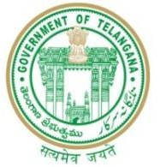

GOVERNMENT OF TELANGANA
TELANGANA TRIBAL WELFARE RESIDENTIAL DEGREE COLLEGE (GIRLS), MAHABUBABAD: MAHABUBABAD-DIST
https://www.ttwrdcs.ac.in/Mahabubabad
E-Mail Id:ttwrdcgirls.mahabubabad@gmail.com Cell No: 790109769

ACADEMIC YEAR 2022-2023

S.NO | DEGREE | Semester | Title of the subject | No.of students appeared | No.of students passed | PASS%
1 | UG | I | Descriptive Statistics and Probability | 9 | 9 | 100%
2 | UG | II | Probability Distributions | 9 | 9 | 100%
3 | UG | III | Statistical methods and Theory of estimation | 22 | 22 | 100%
4 | UG | IV | Statistical Inferences | 22 | 22 | 100%
 |  |  | TOTAL | 62 | 62 | 100%

